CST8116 Optional Practice 01 Sample Solution

# Understand the Problem

I would need to ask the user to give me three numbers, e.g. number1, number2, number3

To get a sum I would add the numbers: sum = number1 + number2 + number3

To get a product I would multiply the numbers: product = number1 * number2 * number3

I would then need to write down the answers and return them to the user to solve their problem.

# Pseudocode

start

declarations

num number1

num number2

num number3

num sum

num product

input number1

input number2

input number3

sum = number1 + number2 + number3

product = number1 * number2 * number3

output sum

output product

stop

# Flowchart

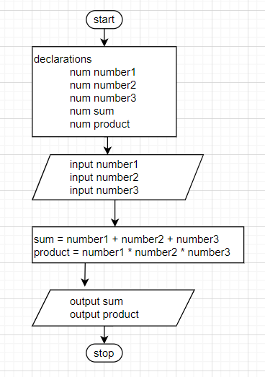

# Test Plan

|  |  |  |  |
| --- | --- | --- | --- |
| Input | Expected Output | Actual Output | Description |
| 2  2  3 | 7  12 | 7  12 | Matches expectations |
| 2  0  3 | 5  0 | 5  0 | Matches expectations, product of zero is zero |
| 1  1  1 | 3  1 | 3  1 | Matches expectations, product of all 1 is 1 |
| 2  -0  3 | 5  -0 | 5  -0 | Matches expectations, product with only one negative zero is negative zero |

These are sample answers, other inputs and outputs are valid for a test plan than the specific ones shown here.